Design: CBOE Helpdesk (HDE4) Enhancements (Cancel Orders)

Overview

Current Cancel Order processing
- Currently the helpdesk users have the following facilities pertaining to the Cancel Orders:
  - Cancel Orders by spreadsheet (Information provided in spreadsheet includes Branch/Branch Seq/User Id and Date)
  - Cancel Orders by Routing Groups (By BC)
  - Cancel Orders by User Group
  - Cancel Orders by Type (GTC/GTD/Day/ALL)
  - Cancel Orders by Date

New requirement
- New Fields to be added to the Existing spreadsheet
  - Order cancellation by specifying the “Gang of five” (Firm/Corr/Branch/Seq/Date)
  - Order cancellation by passing the new field OrsId
- Allow cancels by single or multiple product classes for ALL users
- Allow cancels in multiple product series for ALL users

Scope
This document details out the design of the enhancements over the existing order Cancel functionality triggered from the SA GUI. This includes the server side handling of the cancel request triggered from the GUI. Any GUI design/approaches are not discussed here.

Assumptions
- It is assumed that the spreadsheet containing the information on orders to be cancelled would always be in a fixed format that is pre decided and the parsing will be handled by the GUI. The GUI would send the message (call) to the CD-Server with details for processing cancels

Implementation

Order Cancellation By spreadsheet

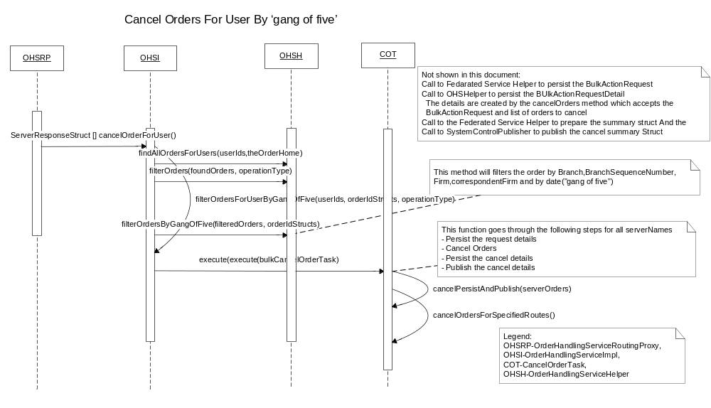
Order cancellation By Spreadsheet by passing “Gang of Five”(Diagram 1)

      - For order cancellation by Spreadsheet OrderHandlingServiceImpl.CancelOrdersForUser() is invoked. This method returns ServerResponseStruct []. It creates CancelOrdersTask object to be passed to execute method of a ThreadPoolExecutor.
      - This method calls to new method filterOrdersForUserByGangOfFive()which is used to
Filter the orders by users, by operation type and finally by ‘gang of five’
      - The method filterOrdersForUserByGangOfFive()calls to
OrderHandlingServiceHelper. findAllOrdersForUsers(userIds,theOrderHome)
To filter the orders by users
      - These filtered orders are further filtered by opearation Types by calling OrderHandlingServiceHelper.filterOrders(foundOrders, operationType)
      - And finally it make call to new method OrderHandlingServiceHelper.filterOrdersByGangOfFive(filteredOrders, orderIdStructs)
To filter the orders by ‘gang of five’(branch , branchSequence number, correpondentFirm, firmNumber and by date)
      - Once the orders get filtered , it makes call to new method CancelOrderTask. cancelPersistAndPublish(serverOrders)

This new method is used to persist the Request details by calling
FederatedServiceHelper.persistBulkActionRequest(),
To cancel the order it calls new method cancelOrdersForSpecifiedRoutes() ,
To persist cancel details it calls OrderHandlingServiceHelper.persistBulkActionDtl()
And finally it publish the cancel details.

      - New method cancelOrdersForSpecifiedRoutes calls to acceptCancel() method of OrderHandlingServiceImpl. This method delegates the call to OrderEntryServiceDelegateImpl and call is given to the workflow.

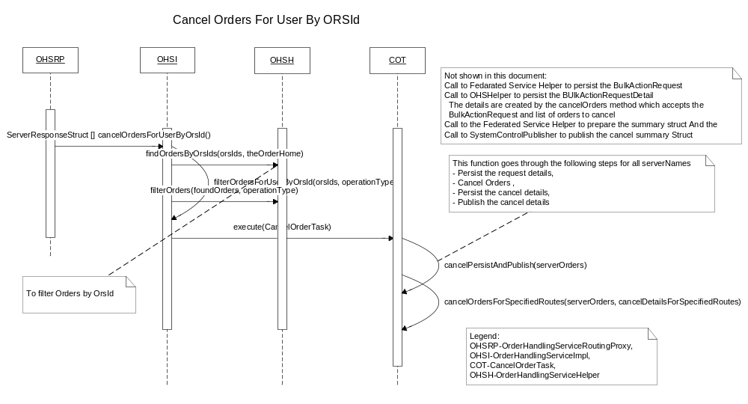

Order cancellation of spreadsheet By passing OrsId.(Diagram 2)

- Order cancellation by OrsId calls new method , OrderHandlingServiceImpl.CancelOrdersForUserByOrsId() is invoked. This method returns ServerResponseStruct []. It creates CancelOrdersTask object to be passed to execute method of a ThreadPoolExecutor.
- cancelOrdersForUserByOrsId () calls to new method filterOrdersForUserByOrsId(orsIds, operationType) to filter the order by OrsId
- This filterOrdersForUserByOrsId() internally makes call to new method
OrderHandlingServiceHelper.findOrdersByOrsIds() to filter the orders by OrsId
and exiting method.
OrderHandlingServiceHelper.filterOrders() to filter the orders by operation Type.

- Once orders get filtered , it makes call to new method CancelOrderTask.
cancelPersistAndPublish(serverOrders)

This new method is used to persist the Request details by calling
FederatedServiceHelper.persistBulkActionRequest(),
To cancel the order it calls new method cancelOrdersForSpecifiedRoutes() ,
To persist cancel details it calls OrderHandlingServiceHelper.persistBulkActionDtl()
And finally it publish the cancel details.

- New method cancelOrdersForSpecifiedRoutes calls to acceptCancel() method of OrderHandlingServiceImpl. This method delegates the call to OrderEntryServiceDelegateImpl and call is given to the workflow

Order cancelation for ALL users

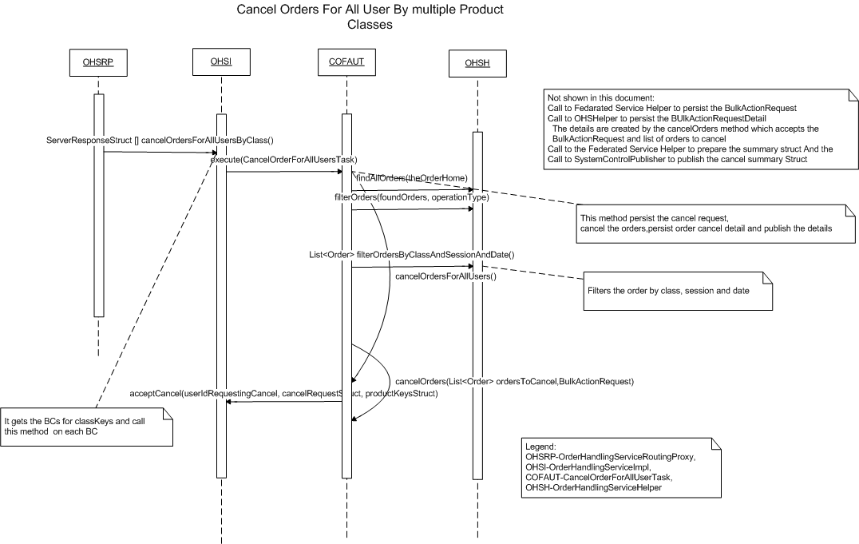
Order cancellation by single or multiple product classes for All users(Diagram 3.)
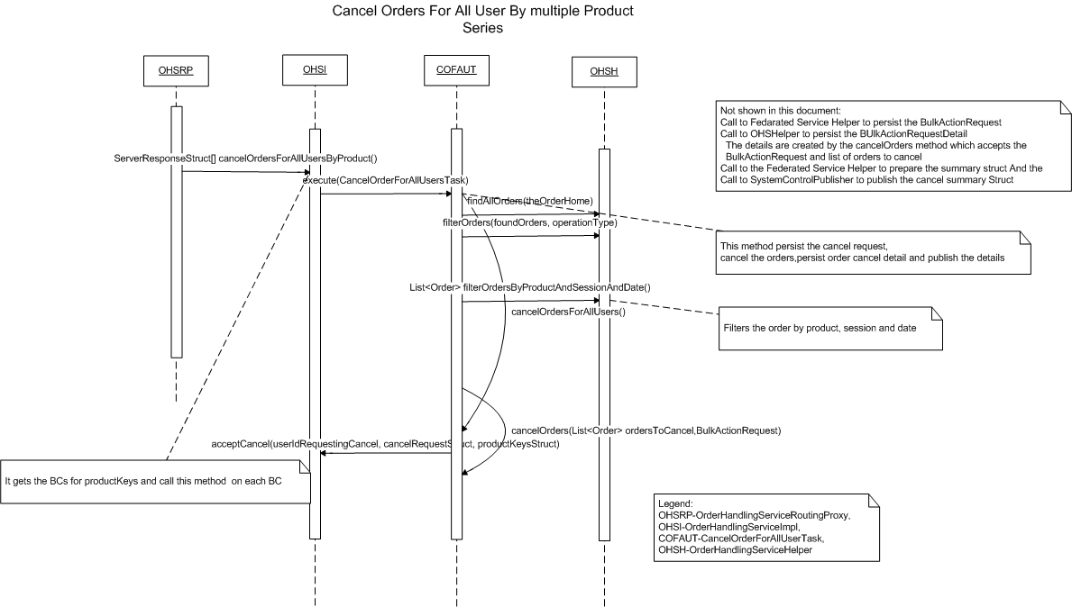

Order cancellation for multiple product series for All users(Diagram 4.)

      - Order cancellation for All users results in calling new methods OrderHandlingServiceImpl.cancelOrdersForAllUsersByClass() for order cancellation for All users by single or multiple product classes and
OrderHandlingServiceImpl.cancelOrdersForAllUsersByProduct() for order cancellation for All users for multiple product series.
These methods returns ServerResponseStruct []. It creates CancelOrderForAllUsersTask(new class) object to be passed to execute method of a ThreadPoolExecutor.

      - CancelOrderForAllUsersTask make calls to cancelOrderForAllUsers(), This method calls existing List<Order> findAllOrders (OrderHome theOrderHome) on OrderHandlingServiceHelper which gives a list of all orders in the system
      - This Order list is passed to filter by operation Type by calling OrderHandlingServiceHelper.filterOrders(List<Order> foundOrders, operationType)
      - After obtaining the list of orders from above, it calls method OrderHandlingServiceHelper. filterOrdersByClassAndSessionAndDate (final List<Order> ordersToFilter, final char[] orderTypes, final boolean currentDate, final int[] classKeys, final String sessionName) that filters the order by class, session and date.
Or it calls filterOrdersByProductAndSessionAndDate(final List<Order> ordersToFilter, final char[] orderTypes, final boolean currentDate, final int[] productKeys, final String sessionName) which filters the order by products, session and date.
An flag is set while creating the instance of CancelOrderForAllUsers, which decides the method
Call between filterOrdersByClassAndSessionAndDate() or filterOrdersByProductAndSessionAndDate() depending on the order cancellation is by class or by product.

      - This list is passed to an private method List<BulkActionDetailWrapper> cancelOrders (List<Order> ordersToCancel, BulkActionRequest request).
      - Here, acceptCancel method of OrderHandlingServiceImpl is invoked. This method delegates the call to OrderEntryServiceDelegateImpl and subsequently to the workflow

- IDL Changes

OrderHandlingService.idl
Location – server/idl/OrderHandlingService.idl
Add a NEW method as follows:
Method triggered if the request is for cancelling orders from spreadsheet by passing only OrsId

util::ServerResponseStructSequence cancelOrdersForUserByOrsId(
in string userIdRequestingCancel,
in string userId,
in string transactionId,
in cmiUtil::DateTimeStruct timestamp,
in cmiUtil::KeyValueStructSequence auditLogProperties,
in short operationType,
in order:: OrsIdSequence orsIds,
)
raises (
exceptions::DataValidationException,
exceptions::CommunicationException,
exceptions::SystemException,
exceptions::AuthorizationException
)

Add below method gets triggered if the request is for canceling orders on all BC’s for All users. The request would filters by: orderType, class and date (today or all)

util::ServerResponseStructSequence cancelOrdersForAllUsersByClass (
in string userIdRequestingCancel,
in string transactionId,
in cmiUtil::DateTimeStruct timestamp,
in cmiUtil::KeyValueStructSequence auditLogProperties,
in short operationType,
in cmiOrder::OrderTypeSequence orderTypes,
in cmiSession::TradingSessionName sessionName,
in cmiProduct::ClassKeySequence classKeys,
in boolean currentDate)
raises(
exceptions::DataValidationException,
exceptions::CommunicationException,
exceptions::SystemException,
exceptions::AuthorizationException
)

Add below method which get trigerred if the request is for cancelling orders on all BC’s for All users (The request will filter by: orderType, productClass and date)
util::ServerResponseStructSequence cancelOrdersForAllUsersByProduct (
in string userIdRequestingCancel,
in string transactionId,
in cmiUtil::DateTimeStruct timestamp,
in cmiUtil::KeyValueStructSequence auditLogProperties,
in short operationType,
in cmiOrder::OrderTypeSequence orderTypes,
in cmiSession::TradingSessionName sessionName,
in cmiProduct::ProductKeyStructSequenence productKeys,
in boolean currentDate)
raises(
exceptions::DataValidationException,
exceptions::CommunicationException,
exceptions::SystemException,
exceptions::AuthorizationException
)

order.idl
Location – vobs/dte/server/domain_idl/order.idl

New type and sequence to accommodate orsId
typedef string OrsId;
typedef sequence <OrsId> OrsIdSequence;

3. Interfaces and Classes
Interfaces:
NA
Classes:

- com.cboe.proxy.businessServices.OrderHandlingServiceRoutingProxy.java
Following NEW methods will be added to this class.
  - public ServerResponseStruct[] cancelOrdersForUserByOrsId(String userIdRequestingCancel, String userId, String transactionId, DateTimeStruct timestamp, KeyValueStruct[] properties, short operationType, String[] orsIds) throws DataValidationException, CommunicationException, SystemException, AuthorizationException
- Delegates the request to executeBulkServiceRequestForUserByOrsId () with all its parameters

  - private ServerResponseStruct[]executeBulkServiceRequestForUserByOrsId (final String userIdRequestingCancel ,String userId,final String transactionId, final DateTimeStruct timeStamp, final KeyValueStruct[] properties, final short operationType, String[] orsIds,) throws DataValidationException, CommunicationException, SystemException, AuthorizationException
- This method gives a calls FederatedServiceHelper.getServiceRoutes (Map routeMap). A list containing all valid BC names is returned.
- After the list is obtained a call is given to cancelOrdersForUserByOrsId() method of OrderHandlingServiceImpl for each serviceRoute.
- In case of any exception in the processing, a method ServerResponseStruct [] getServerResponseStruct (String serverId, short errorCode, String description) is called.

  - public ServerResponseStruct[]cancelOrdersForAllUsersByClass(String userIdRequestingCancel, String transactionId, DateTimeStruct timestamp,KeyValueStruct[] properties, short operationType, char[] orderTypes,String sessionName, int[] classKeys, boolean currentDate) throws DataValidationException, CommunicationException, SystemException, AuthorizationException
- Delegates the request to executeBulkServiceRequestForAllUsersByClass () with all its parameters.
  - private ServerResponseStruct[]executeBulkServiceRequestForAllUsersByClass (final String userIdRequestingCancel, final String transactionId, final DateTimeStruct timestamp, final KeyValueStruct[] properties, final short operationType, final char[] orderTypes , String sessionName, final int[] classKeys, final boolean currentDate)throws DataValidationException, CommunicationException, SystemException ,AuthorizationException

- It iterates through the classes passed to this method and for each class , it finds the BC using the session name.
- It finds the List of classes for each BC, and Map each BC with list of classes
- For each BC it makes call to cancelOrderForAllUsersByClass() method of OrderHandlingServiceImpl by passing only the classkeys mapped with
that BC.

  - public ServerResponseStruct[]cancelOrdersForAllUsersByProduct(String userIdRequestingCancel, String transactionId, DateTimeStruct timestamp,KeyValueStruct[] properties, short operationType, char[] orderTypes,String sessionName, int[] productKeys, boolean currentDate) throws DataValidationException, CommunicationException, SystemException, AuthorizationException
- Delegates the request to executeBulkServiceRequestForAllUsersByProduct() with all its parameters.
  - private ServerResponseStruct[]executeBulkServiceRequestForAllUsersByProduct (final String userIdRequestingCancel, final String transactionId, final DateTimeStruct timestamp, final KeyValueStruct[] properties, final short operationType, final char[] orderTypes , String sessionName, final int[] productKeys, final boolean currentDate)throws DataValidationException, CommunicationException, SystemException ,AuthorizationException

- It iterates through the productKeys passed to this method and for each productKey along with session name , it finds the BC.
- It finds the List of products for each BC, and Map each BC with products.
- For each BC it makes call to cancelOrderForAllUsersByProduct() method of OrderHandlingServiceImpl by passing only productKeys
which are associate with This BC.

- com.cboe.ohs.receivers.ohs.OrderHandlingServiceImpl.java
NEW methods will be added to this class.
  - Public List<Order> filterOrdersForUserByGangOfFive(String[] userIds, OrderIdStruct[] orderIdStructs, short operationType)
- This new method is used to filter the orders by users, opearation types and by ‘gang of five’ by calling methods
OrderHandlingServiceHelper.findAllOrdersForUsers(),
OrderHandlingServiceHelper.filterOrders(foundOrders, operationType), and OrderHandlingServiceHelper.filterOrdersByGangOfFive(filteredOrders, orderIdStructs);

  - public ServerResponseStruct[] cancelOrdersForUserByOrsId(String userIdRequestingCancel, String userId, String transactionId, DateTimeStruct timestamp,KeyValueStruct[] auditLogProperties, short operationType, String[] orsIds
) throws DataValidationException, CommunicationException,
SystemException, AuthorizationException
- This method calls new method filterOrdersForUserByOrsId(orsIds, operationType) to filter the order by OrsId and operation Type
- Calls ThreadPoolExecutor.execute(bulkCancelOrderTask)

  - private List<Order> filterOrdersForUserByOrsId(String[] orsIds, short operationType)
- This method calls new method OrderHandlingServiceHelper.findOrdersByOrsIds(orsIds, theOrderHome)
To filter the order by OrsId
- Calls OrderHandlingServiceHelper.filterOrders(foundOrders, operationType) to filter the order by operation Type.

  - public ServerResponseStruct[]cancelOrdersForAllUsersByClass(String userIdRequestingCancel, String transactionId, DateTimeStruct timestamp,KeyValueStruct[] properties, short operationType, char[] orderTypes, String sessionName, int[] classKeys, boolean currentDate) throws DataValidationException, CommunicationException, SystemException, AuthorizationException
- This method firstly validates the inputs userIdRequestingCancel, workstationID,operationType and invoke the CancelOrderForAllUsersTask Thread.(new class)

  - public ServerResponseStruct[]cancelOrdersForAllUsersByProduct(String userIdRequestingCancel, String transactionId, DateTimeStruct timestamp,KeyValueStruct[] properties, short operationType, char[] orderTypes, String sessionName, int[] productKeys, boolean currentDate) throws DataValidationException, CommunicationException, SystemException, AuthorizationException
- This method firstly validates the inputs userIdRequestingCancel, workstationID,operationType and invoke the CancelOrderForAllUsersTask Thread.(new class)

  - public String getRouteName(int key, boolean classKey) throws DataValidationException
- This method is internally called by cancelOrdersForAllUsersByProduct()
And cancelOrdersForAllUsersByClass() to get the routingName for
Passed product class or classKeys.

  - private List<Order> filterOrdersForUsers(String[] userIds, short operationType)
- It finds all the orders for passed UserId by calling
OrderHandlingServiceHelper.findAllOrdersForUsers()
- And filter these orders by Operation Type by calling
OrderHandlingServiceHelper.filterOrders() and return these filtered order List

  - private List<Order> filterOrdersForUsers(String[] userIds, short operationType,
char[] orderTypes, String[] correspondentFirmValues, int[] classKeys, boolean currentDate)
- It finds all the orders for passed userId by calling
OrderHandlingServiceHelper.findAllOrdersForUsers()
- Then it filters these orders by operation Type, These filtered orders will contain only the ORDERS or IORDERS
OrderHandlingServiceHelper.filterOrders()
- This filtered List is further filtered by class, correspondent Firm, by date
And by order Type by calling
OrderHandlingServiceHelper.filterOrdersForRequestedUsers()
.
  - private String[] getServerNamesForOrders(List<Order> ordersToCancel)
- This method is used to fetch the Server Names from the orders passed to methods.

  - private Map<String, List<Order>> getServerNamesMapForOrders(List<Order> ordersToCancel)
- This method is used to fetch the Map of serverNames and respective list of orders
  - private String[] convertStringSetToArray(Set<String> serverNames)
- This method is used to
Convert Set<String> to String [].

- com.cboe.ohs.receivers.ohs.OrderHandlingServiceHelper.java
Below mentioned NEW methods will be added to this class.

  - public static List<Order> filterOrdersByGangOfFive(final List<Order> ordersToFilter, OrderIdStruct[] orderIdStruct)
- This method iterate the Orders from ordersToFilter with each entry of
orderIdStruct
- If order from ordersToFilter match with the entry of orderIdStruct for parameters branch, branchSequence number, firm, correspondentFirm and date , then this order is added to an list for cancellation.
  - public static List<Order> findOrdersByOrsIds(final String[] orsIds,OrderHome orderHome)
- It filter the orders by using orderHome.findOrderByOrsId()
And return the filtered order List

  - public static List<Order> filterOrdersByClassAndSessionAndDate(final List<Order> ordersToFilter, final char[] orderTypes, final boolean currentDate, final int[] classKeys, final String sessionName)
- This method filters the passed order List by classKeys, session and by date
And returns the filtered order List.

  - public static List<Order> filterOrdersByProductAndSessionAndDate(final List<Order> ordersToFilter, final char[] orderTypes, final boolean currentDate, final int[] productKeys, final String sessionName)
- This method is used to filter the orders by product keys, session and date.
And returns the filtered order List.

- com.cboe.ohs.receivers.ohs.CancelOrderTask.java
Below mentioned NEW methods will be added to this class.

New constructor
  - public CancelOrderTask(OrderHandlingService orderHandlingService,
OrderHome orderHome, BulkActionDtlHome bulkActionDetailHome,
BulkActionRequestHome bulkActionRequestHome,
SystemControlConsumerHome systemControlConsumerHome,
String userIdRequestingCancel,ProductDataCache productDataCache,String[] userIds, String transactionId, DateTimeStruct timeStamp,
KeyValueStruct[] auditLogProperties,int cancelBulkSize,
int cancelBulkWait, final short operationType, Map<String,List<Order>> serverOrders)
{
this.orderHandlingService = orderHandlingService;
this.theOrderHome = orderHome;
this.bulkActionDetailHome = bulkActionDetailHome;
this.bulkActionRequestHome = bulkActionRequestHome;
this.systemControlConsumerHome = systemControlConsumerHome;
this.productDataCache = productDataCache;
this.userIdRequestingCancel = userIdRequestingCancel;
this.userIds = userIds;
this.transactionId = transactionId;
this.timeStamp = timeStamp;
this.properties = auditLogProperties;
this.cancelBulkSize = cancelBulkSize;
this.cancelBulkWait = cancelBulkWait;
this.operationType = operationType;
this.serverOrders = serverOrders;
}
  - private void cancelPersistAndPublish(Map<String, List<Order>> serverOrders)
- run() makes call to this method .
- This method is used to persist the request details by calling
FederatedServiceHelper.persistBulkActionRequest()
- To cancel the order, it calls new method cancelOrdersForSpecifiedRoutes()
- Persist the order cancel details by calling
OrderHandlingServiceHelper.persistBulkActionDtl()
- And finally publish order cancel details

  - private Map<String, ServerCancelDetails> cancelOrdersForSpecifiedRoutes(Map<String, List<Order>> serverOrders,
Map<String,ServerCancelDetails> cancelDetailsForMultipleRoutes)
- This new method cancels the orders and returns notification of orders being sent for cancellation.
- Order cancellation is done on each RouteName from serverOrders List.
Where it finds the orders to be cancelled for each RoteName and cancels the order by calling orderHandlingService.acceptCancel()

CLASSES:
Add a new class com.cboe.ohs.receivers.ohs. CancelOrdersForAllUserTask.java
public Class CancelOrdersForAllUserTask implements BulkTask

Constructor:-
  - public CancelOrdersForAllUserTask(OrderHandlingService orderHandlingService,
OrderHome orderHome, BulkActionDtlHome bulkActionDetailHome,
BulkActionRequestHome bulkActionRequestHome, SystemControlConsumerHome systemControlConsumerHome, String serverName,
String userIdRequestingCancel, ProductDataCache productDataCache,
,String transactionId, DateTimeStruct timeStamp,
KeyValueStruct[] auditLogproperties, int cancelBulkSize, int cancelBulkWait, final short operationType, final char[] orderTypes,String sessionName,
int[] classKeys, boolean currentDate, boolean classes)

Add the following methods:
  - public void run()
makes call to cancelOrdersForAllUsers()

  - private void cancelOrdersForAllUsers()
- In this method an object of BulkActionRequest is created by calling existing method FederatedServiceHelper.persistBulkActionRequest (). This object contains information like timeStamp, userIdRequestingCancel, operationType, orderType, transactionId, serverName and properties object. This method saves this information in database table bulk_action_request.
- After this data is persisted, an existing method List<Order> findAllOrders (OrderHome theOrderHome) of OrderHandlingServiceHelper.java to fetch the complete orders in system.
- On this order list a filter is applied by calling an existing method filterOrders (List<Order> ordersToFilter, short operationType) to filter the orders by operationTypes.
- Once it collects the filtered orders List, It checks the flag classes
If it is true it calls new method
OrderHandlingServiceHelper. filterOrdersByClassAndSessionAndDate() to filter the order by class keys and session.
If it is false it calls new method
OrderHandlingServiceHelper. filterOrdersByProductAndSessionAndDate() to filter the orders by product keys and session.
- Next, an private method cancelOrders () gets called. This method returns list of BulkActionDetailWrapper objects which are persisted later with a call to persistBulkActionDtl() method of OrderHandlingServiceHelper.
- The information is published back to GUI by calling method prepareFederatedResponseSummaryStruct() FederatedServiceHelper.java

  - private List<BulkActionDetailWrapper> cancelOrders(List<Order> ordersToCancel,BulkActionRequest request)
- For each order from the Orders to cancel,
It calls to orderHandlingService.acceptCancel() to cancel the order.
This method delegates the call to OrderEntryServiceDelegateImpl and subsequently to the workflow

Logging
1. Informative messages will be logged at the beginning and end of each important method.

Exception Handling
All the exceptions will be logged and propagated to the top level (i.e. the SA GUI)

Scripts(2)
None

Database(.5)
None

SetContext(.125)
None

XML/DTD(.5)
None

Homes/Services(2)
- OrderHandlingService

ImplPlan(.5)
None

PerformanceTestingProcedure(1)
Yes << To Be specified later >>

TestingProcedure(1)
None

OperatorProcedure(.5)
None

Fallback/Failover
None

GUI Design
NA

List of Files
- For Idl changes

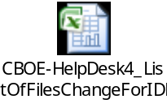
Queries
- Can we add this new method to filter the order by FirmNumber
Answer:- Yes, we can modify OrderHandlingServiceHelper.java to add new method to filter the order by Firm number.
- This Firm passed from SA GUI will be FirmNumber or name?
Answer:- This should be the Firm number which is passed in as
orderIdStructs.executingOrGiveUpFirm.firmNumber
- BaseOrderImpl.executingOrGiveUpFirmNumber is the same FirmNumber that we are interested or it is something different?
Answer:- Yes.
- Can we have the date from orderIdStructs As there is field orderDate in orderIdStructs ?
Answer:- Yes
- What would be the other criteria for filtration of order along with OrsId ? oprationType, users and OrsId will be sufficient?
Answer:- The rationale being when GTC or GTD (Note: As of now the GUI does not support injecting GTD!) are sent in the ORSID is not duplicated over the next day that ID remains with the order unless it is cancelled or fully traded so we do not need the date even if it previous day order we can identify it by the ORSID alone.

